Johnathan Doe Publisher

PO Box 555

Mount Vernon, IL. 62864

**Mr. and Mrs. Eckelberry**

**123 E Galaxy Dr**

**Woodlawn, IL. 62898**

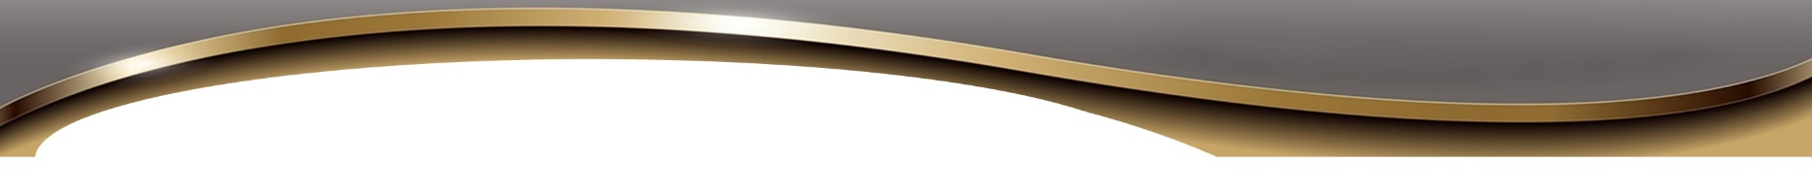

Claudine A Young

PO Box 555  
Any Town IL. 62864  
 (555) 555-5555

December 1, 2020

Mr. and Mrs. Eckelberry

123 E Galaxy Dr

Woodlawn, IL. 62898

Dear Mr. and Mrs. Eckelberry:

As a neighbor I wanted to inquire of your well being with the outbreak of the Covid pandemic. I hope that you and your loved ones are faring well during these troublesome times.

With so many of us being quarantined, many are challenged to stay occupied with wholesome and productive activity. Perhaps you would agree that few undertakings are as rewarding as enhancing our knowledge of the Bible, the world's most popular book. If you and your family are interested in learning more about the Bible through study or discussion, my wife Claudine and I currently have openings in our schedule and would love to spend some time with you. We conduct personal weekly Bible discussions with Mount Vernon residents via Zoom. We have enjoyed lively interactive discussions with many of our neighbors over the years with the focus on answering Bible questions and helping you get the most out of your own copy of the Bible. A session may be as short as 10 minutes or up to an hour or more. You choose how long and how often. Claudine and I strive to provide satisfying answers to life's big questions such as why does God allow suffering or what is the purpose of life? We welcome nonjudgemental exchanges with peoples of all faiths and backgrounds.

Please contact me at 618-246-8822 or email at fred@il4rbc.com. If you prefer an online curriculum, visit our website at JW.org. (Currently in over 1,000 languages) This link will take you directly to the online course: https://www.jw.org/en/bible-teachings/online-lessons/how-the-lessons-work/ Remember, the Bible's wisdom can help you and your family to enjoy life now, and gain a positive hope for the future. Looking forward to hearing from you.

Sincerely,  
Claudine A. Young

Claudine A. Young

